
INTERNET PROGRAMMING AND MOBILE
PROGRAMMING

PROJECT 3: Design and Implementation of a Crowdsensed Drive Test
Mobile Application for Coverage Prediction

TASK 5: UI DESIGN AND IMPLEMENTATION

GROUP 10

GROUP MEMBERS
 | Name Of Member | Matricule
1 | Asangana Paul Fleming | FE23A014
2 | Fontem Junior Nkonganyik | FE23A063
3 | Suinyuy Mathias Mahla | FE23A144
4 | Nfor Godwill Kongnje | FE23A108
5 | Ronald Namwene Vefonge | FE22A295

Content
Table of content 2
1.0 Introduction 3
2.0 App identity .................................................................................................................................3
2.1 Application Name: “SignalSense” 3
2.2 Brand Identity 3
2.3 App Logo 4
2.4 Color Identity 4
2.5 Typography 4
2.6 User-Centered Design Approach 5
3.0 Visual Design 5
3.1 Design Overview 5
3.2 Design Objectives 5
3.3 Navigation Design 6
3.4 Dashboard Design 6
3.5 Data Collection Interface 7
3.6 Coverage Monitoring Screens 7
4.0 Frontend Implementation 8
4.1 Introduction 8
4.2 Why Flutter Was Selected 8
4.3 Flutter Architecture Used 9
4.4 Dashboard Implementation 9
4.5 Measurement Collection Module 10
4.6 Offline Data Management 11
4.7 Frontend Security Features 11
4.8 Challenges Encountered 11
5.0 Summary 11
Conclusion 12

1.0 Introduction
The user interface (UI) design of the Crowdsensed Drive Test Mobile Application plays a critical role in ensuring usability, accessibility, and efficient data collection. Since the application is intended to be used by ordinary smartphone users to collect network performance measurements, the interface must be intuitive, lightweight, and easy to navigate regardless of the user's technical expertise.

The application's identity was designed around the concept of mobile network monitoring, coverage analysis, and crowdsourced data collection. Every design decision was guided by the project's objective of enabling users to contribute cellular network measurements while maintaining a simple and engaging user experience.

2.0 App Identity

2.1 Application Name: “SignalSense”
- The name SignalSense was chosen to represent the application's primary purpose of intelligently sensing, collecting, and analyzing mobile network signal information. The term combines two key concepts: "Signal," which refers to the cellular network measurements gathered from smartphones, and "Sense," which emphasizes the application's ability to detect, monitor, and interpret network conditions in real time.

- The name reflects the system's role in capturing valuable radio network parameters such as signal strength, signal quality, cell identification information, and geographic location data from multiple users. Through crowdsourced sensing, the application contributes to the generation of network coverage insights and supports the identification of areas experiencing poor connectivity or coverage deficiencies.

- Furthermore, the name conveys the application's focus on intelligent network awareness and data-driven decision-making. It presents the system as a modern technological solution capable of transforming ordinary smartphones into powerful sensing devices for mobile network monitoring and coverage prediction.

- Overall, SignalSense provides a concise, memorable, and professional identity that clearly communicates the application's functionality and objectives to users, researchers, network operators, and other stakeholders involved in mobile network performance assessment.

2.2 Brand Identity
The application's identity was designed to reflect:
- Connectivity
- Network intelligence
- Mobility
- Data collection
- Coverage prediction
- Modern digital technology

The overall branding promotes trust, reliability, and technical sophistication, which are important qualities for a network monitoring platform.

2.3 App Logo
The proposed logo combines:
- Cellular signal bars
- Wireless communication symbols
- Location/GPS markers
- Data transmission indicators

These elements visually represent the process of collecting georeferenced network measurements and transmitting them to a backend platform for analysis.
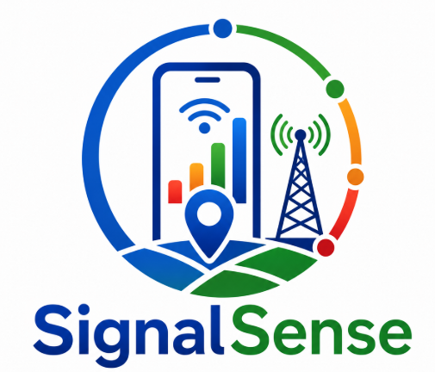
Figure 1: Application Logo

2.4 Color Identity
The color palette was selected to align with modern technology applications and telecommunications systems.

Color | Purpose
Blue | Trust, communication, reliability
Green | Network health and successful measurements
Orange | Warnings and weak signal conditions
Red | Coverage holes and poor network areas
White | Clean and readable interface

These colors help users quickly understand network conditions and application status.

2.5 Typography
The application uses modern mobile-friendly fonts that enhance readability across different screen sizes.
Typography objectives include:

Readability: Readability ensures that information displayed within the application is clear, organized, and easy to understand. Appropriate font sizes, spacing, and visual hierarchy help users quickly interpret network measurements and system information.

Consistency: Consistency involves maintaining uniform design elements, layouts, colors, typography, and navigation patterns throughout the application. This creates a predictable user experience and makes the system easier to learn and use.

Professional Appearance: A professional appearance is achieved through clean layouts, modern design principles, organized content, and a well-chosen color scheme. This enhances user confidence and reinforces the credibility of the application as a network monitoring tool.

Accessibility: Accessibility ensures that the application can be effectively used by a wide range of users. Clear text, intuitive navigation, sufficient color contrast, and touch-friendly controls improve usability and encourage broader participation in crowdsourced data collection.

The chosen font style provides clear visibility for:
- Signal measurements
- Location information
- Coverage statistics
- System notifications
- Navigation menus

2.6 User-Centered Design Approach
The design process followed a user-centered approach to ensure that the application remains usable for both technical and non-technical users.
Key principles applied include:
- Simplicity
- Consistency
- Accessibility
- Minimal user effort
- Real-time feedback
The interface minimizes unnecessary interactions while maximizing data collection efficiency.

3.0 Visual Design

3.1 Design Overview
The visual design of the Crowdsensed Drive Test Mobile Application was developed using Figma as the primary UI/UX design tool.

The design prototype can be accessed through the following Figma project:
Figma Design Prototype:
https://www.figma.com/design/rmgpSjdOEEgGXqQf7AJY0j/Network-tracking-system

The prototype served as a blueprint for frontend development and ensured consistency throughout the implementation phase.

3.2 Design Objectives
The visual design was guided by the following objectives:
- Provide an intuitive user experience.
- Display network measurements clearly.
- Support real-time monitoring activities.
- Reduce cognitive load on users.
- Ensure responsive design across devices.
- Maintain visual consistency.
- No registration into the system to ensure user confidentiality

3.3 Navigation Design
The navigation structure was designed to allow users to easily move between major system functions.
Core navigation areas include:
- Dashboard
- Network Monitoring
- Measurement Collection
- Coverage Analysis
- User Profile
- Settings
This structure minimizes the number of interactions required to access key features.

3.4 Dashboard Design
The dashboard acts as the central control panel of the application.
Key information displayed includes:
- Current signal strength
- GPS location
- Measurement statistics
- Data synchronization status
- Network information
- Coverage indicators
The dashboard provides users with a quick overview of system status and collected measurements.

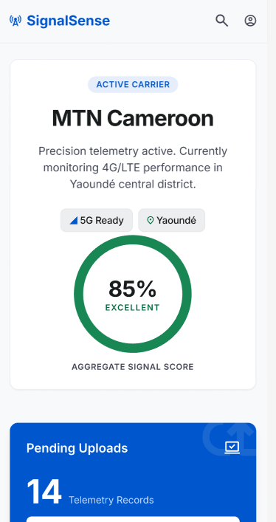
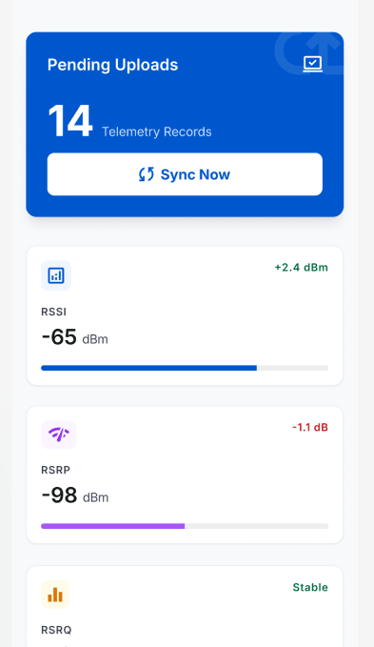

Figure 2: Dashboard Interface Design

3.5 Data Collection Interface
The data collection screen was designed to simplify the measurement acquisition process.
The interface displays:
- RSRP values
- RSRQ values
- SINR values
- RSSI values
- Cell ID
- GPS coordinates
- Timestamp information
Users can monitor measurements as they are collected in real time.

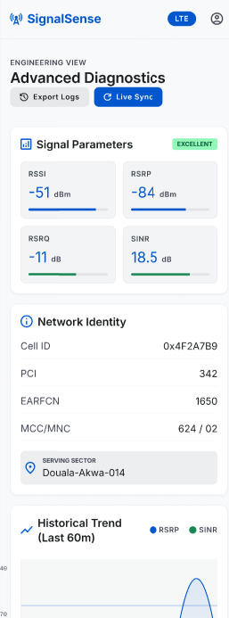
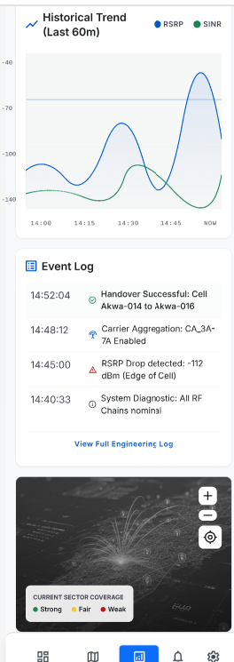
Figure 3: Network Measurement Collection Screen

3.6 Coverage Monitoring Screens
Coverage monitoring interfaces allow users and administrators to visualize network quality information.
These screens present:
- Signal strength indicators
- Coverage quality levels
- Weak signal alerts
- Location-based measurements
Visual indicators improve understanding of network performance conditions.

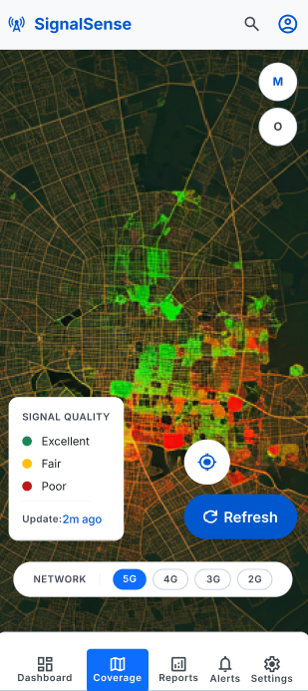

Figure 4: Coverage Monitoring Interface

4.0 Frontend Implementation

4.1 Introduction
- The frontend component of the Crowdsensed Drive Test Mobile Application was implemented using Flutter and Dart.

- Flutter is Google's modern cross-platform application development framework that enables developers to create high-performance mobile applications from a single codebase.

- Dart serves as the primary programming language for implementing application logic and user interface functionality.

4.2 Why Flutter Was Selected
Flutter was selected because it offers several advantages relevant to this project.

Cross-Platform Development
Flutter enables the development of applications for both Android and iOS using a single codebase. This significantly reduces:
- Development time
- Maintenance costs
- Code duplication

Flutter provides excellent scalability for a crowdsensing application that may later be deployed across multiple platforms.

High Performance
Flutter compiles directly into native machine code, resulting in:
- Faster execution
- Smooth animations
- Responsive interfaces
- Reduced latency
This is particularly important for applications that continuously collect and display real-time network measurements.

Rich UI Components
Flutter provides a comprehensive collection of widgets that facilitate the development of modern and visually appealing user interfaces.
Examples include:
- Cards
- Charts
- Buttons
- Forms
- Navigation components
- Maps integration
These widgets were leveraged to create an intuitive user experience.

Hot Reload Capability
Flutter's Hot Reload feature accelerated frontend development by allowing rapid testing and refinement of UI components without restarting the entire application.
This significantly improved development productivity.

4.3 Flutter Architecture Used
The application frontend follows a structured architecture consisting of:
- Presentation Layer
- Business Logic Layer
- Data Layer
This separation improves:
- Maintainability
- Scalability
- Reusability
- Code organization

4.4 Dashboard Implementation
The dashboard was implemented using Flutter widgets to provide real-time access to collected network information.
Displayed information includes:
- Signal quality
- Current network
- Device location
- Upload status
- Measurement count

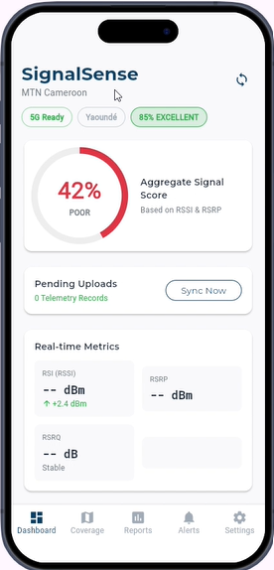

Figure 5:
Implemented Dashboard

4.5 Measurement Collection Module
The measurement collection module interfaces with device APIs to obtain:
- RSRP
- RSRQ
- SINR
- RSSI
- Cell ID
- GPS coordinates
- Timestamps
The collected information is presented through dynamic Flutter widgets and updated in real time.

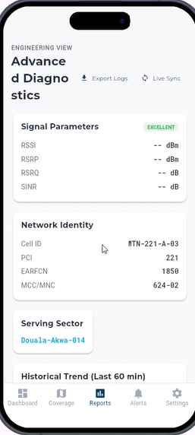
Figure 5.10: Measurement Collection Module

4.6 Offline Data Management
Flutter local storage mechanisms were integrated to support offline functionality.
Benefits include:
- Continuous measurement collection
- Temporary local storage
- Automatic synchronization
- Reduced data loss
This functionality is critical when users travel through areas with poor connectivity.

4.7 Frontend Security Features
The frontend implementation includes:
- Secure authentication handling
- Input validation
- Permission management
- Session protection
These measures contribute to maintaining data integrity and user privacy.

4.8 Challenges Encountered
Several challenges were encountered during implementation, including:
- Accessing cellular network APIs.
- Managing device permissions.
- Handling GPS accuracy variations.
- Supporting offline data collection.
- Maintaining UI responsiveness during continuous measurements.
These challenges were addressed through iterative testing and optimization.

5.0 Summary
The frontend implementation successfully transformed the UI designs developed in Figma into a fully functional Flutter application. Through the use of Flutter and Dart, the project achieved a modern, scalable, and cross-platform architecture capable of supporting crowdsourced network measurement collection, offline storage, secure synchronization, and future expansion to additional platforms. The implemented interface provides an effective interaction layer between users and the backend coverage prediction system, thereby contributing to the overall goal of mobile network coverage analysis and coverage hole detection.

Conclusion
- The UI design and frontend implementation phase successfully transformed the project requirements into a functional and user-friendly mobile application. Through the development of a clear application identity, a well-structured visual design, and an interactive frontend interface, the SignalSense application provides an effective platform for crowdsourced mobile network measurement collection and coverage analysis.

- The design process emphasized usability, readability, consistency, accessibility, and professional presentation to ensure that users can easily interact with the system and understand the information being displayed. The visual interfaces were first modeled using Figma, allowing the design concepts to be refined before implementation. These prototypes served as a foundation for developing a consistent and intuitive user experience across all application screens.

- The frontend was implemented using Flutter and Dart, enabling the creation of a high-performance and cross-platform mobile application from a single codebase. This approach not only reduced development complexity but also provides flexibility for future deployment on multiple platforms, including Android and iOS devices. Furthermore, Flutter's rich widget ecosystem and responsive design capabilities contributed to the development of a modern and scalable user interface.

- Overall, the completed UI design and frontend implementation establish a strong foundation for the SignalSense system. The resulting application effectively supports the collection, visualization, and management of cellular network measurements while providing a seamless user experience. This stage therefore represents a significant milestone toward achieving the project's overall objective of enabling crowdsensed drive testing for mobile network coverage prediction and coverage hole detection.

